Producing 3D point cloud and digital elevation models through the use of unmanned aerial vehicles, Historic St. Luke’s Church case study

Tangee Beverly, Corneluis Holness,
Nigel Pugh, Tori Wilbon
Center of Excellence in Remote Sensing
Education and Research
Elizabeth City State University
Elizabeth City, North Carolina 27909
E. Clay Swindell
North Carolina Department of Cultural Resources
Museum of the Albemarle
Elizabeth City, North Car

Abstract— This research project was initiated to demonstrate the ability of Unmanned Aerial Vehicles (UAV) to gather elevation and 3D data using only a visible light camera. The chosen test case was the structure and property associated with Historic St. Luke’s Church. This historic property represents Virginia’s oldest standing church built in the late 17th century. While the property area associated with the church covers several acres, The UAV team chose to focus on the historic structure and immediate surrounding area. The intention was to fly a DJI Phantom 2 Vision+ UAV along a gridded flight plan designed to capture an array of images at defined intervals. These images were subsequently processed with the Pix4d software to produce an image mosaic of the gridded area, a 3d point cloud and digital elevation model (DEM), and finally a 3D model of the historic structure. The dataset will expand on the historical and the geographic placement of the structure and will assist Historic St. Luke's in directing future archaeological and landscape studies on the property.
Keywords—archaeology, aerial imagery, DJI Phantom 2 Vision+, drone, UAV

introduction
Throughout previous years, the use of UAV technology has become more prevalent in today's society. UAVs have emerged from expensive unconventional property to being used for inexpensive personal recreational use. The accessibility to UAVs and its capabilities offer advantages in obtaining aerial imagery and structural elevation models that have many applications including uses in humanitarian response, environmental studies, remote sensing research, and archaeological studies.
Evaluating emerging technologies like UAVs have always aided archaeology and provided archaeologists with the ability to identify and study sites without having to disturb them. Remote sensing, as it is called, affords researchers the ability to study sites and landscapes in a non-destructive manner and allows them to focus their limited resources on areas likely to yield results. While the process of remote sensing archaeological sites has been around for many decades, modern advances in UAV technology make it much more accessible to smaller teams and projects.
Researchers and students at the Center of Excellence in Remote Sensing Education and Research (CERSER) program at Elizabeth City State University decided to explore the potential of UAVs to aid archaeological studies in the region. The primary goal of this research was to produce aerial imagery from which structural and elevation models could be generated. The team focused on the historical landmark St. Luke's Church located in Smithfield, Virginia.

Objective
The primary objective for this project was to produce aerial imagery from which structural and elevation models could be generated. A secondary objective was to make this data available to the church so that it could be used in future archaeological and landscape studies. To achieve these objectives, The project made use of an UAV platform equipped with a visible light camera to produce a series of images the software could interpolate 3D information.

methodology

Area of Interest (AOI)
The Area of Interest (AOI) was St. Luke’s is a historical landmark located in Smithfield, Virginia (Figure 1 & Figure 2) [2]. St. Luke's was previously known as The Newport Parish Church, also known as the “Old Brick Church”. St Luke’s is considered to be one of the oldest surviving ecclesiastical buildings in the state of Virginia. Longstanding tradition says it was built in the early 1630’s however a more recent dendrochronology study points to the original structure being built in the early 1680’s. This church is a brick building with a unique tower with gothic styling. Reverend W. G. H. Jones informally renamed the church St. Luke’s in 1828.
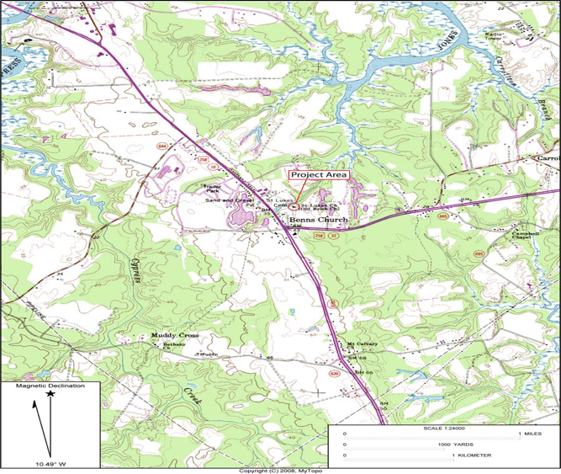
Fig 1. Area of Interest located in Smithfield, VA
The church was designated a National Historic Landmark by the Secretary of the Interior in 1960; it was then listed in the National Register of Historic places in 1966 and the Virginia Landmarks Register in 1969 [4]. Most recently, Historic St. Luke’s Restoration, Inc. conveyed an historic preservation easement over a 1.0-acre portion of the property to the VDHR in September 2010 as a condition of a Save America’s Treasures grant.
St. Luke’s church has had previous archaeological investigations and excavations. The first excavation took place in 1894. Colonel Joseph Bridger was removed from his plantation and buried in the church’s chancel. In the 1950’s excavations were revealed three successive masonry floors. The first archaeological investigation took place in January 2007 when Archaeological & Cultural Solutions Inc. (ACS) and the Smithsonian Institution analyzed the remains of Colonel Joseph Bridger. In the same year ACS monitored the trenching for a new storm water drainage system. The excavations of the trenches measured 60 feet long, 5 feet wide, and 2 feet deep. These excavations bore ten unmarked graves.
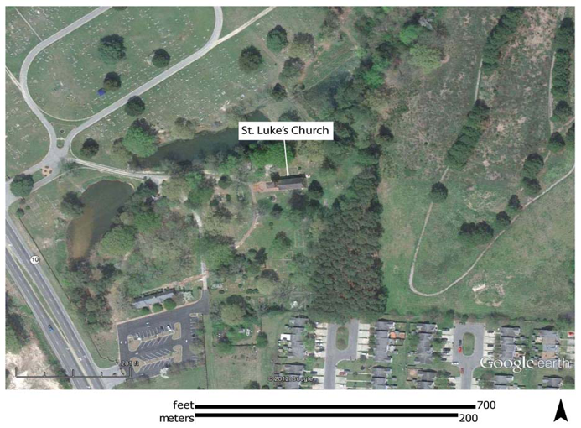
Fig 2. Aerial Image of Historic St. Luke’s Church

Equipment
The primary piece of equipment used to conduct this research was the DJI Phantom 2 Vision+ UAV with a built-in Naza-M V2 Flight Control System and integrated gimbal and camera (Figure 3) [1]. The Phantom 2 Vision+ is a two-pound remote-controlled quad copter that contains four rotating wings capable of stable flight and taking high resolution pictures and video.
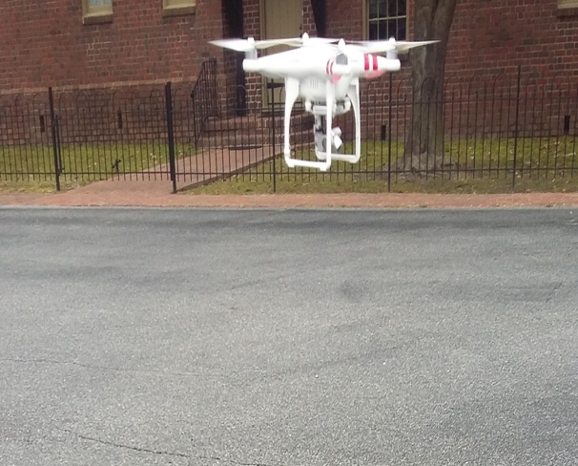
Fig 3. DJI Phantom 2 Vison+ UAV
The video is captured at 1080 pixels/30 frames per second and 720 pixels/60 frames per second, and contains the option for the user to shoot slow motion video [1]. The JPEG type photos taken at 14 megapixels are captured by the camera operated on a stabilizer, which is a benefit that eliminates unsteady video and images caused by the four motors. The UAV can operate autonomously or with minimal pilot training, fly at and up to 1000 ft. in calm wind and as fast as 15 meters/second with the four basic directions of flight pitch (forwards and backwards), roll (left and right), elevator (up and down) and yaw (turn left or right) [1]. The DJI has a built-in inertial sensor and a barometric altimeter that measures both attitude and altitude. Also, the quad copter operates on a flight time of approximately 25 minutes [1].
In retrospect, the DJI Phantom 2 Vision+ UAV turned out to be very cost effective and versatile regarding its numerous functions and uses.

Developing a Flight Plan
Pix4d iOS application was utilized on an iPhone 6s for the creation of creating three flight plans. The parameters for the flights taken were 125 x 89 meters, which is large enough to cover the area of interest (Figure 4). A total of two aerial image flights were taken, with the longest flight time recording at 8 minutes and 58 seconds. A third and final (manual) flight was taken using to record oblique images and video of St. Luke’s church at 150 feet. There were a total of 147 pictures taking during the three on-site flights. This overlap is necessary for the creation of the larger mosaic.
Despite the UAV’s ability to fly missions on its own, it is still necessary to plot the linear transects prior to flight. It is also important to plot out the mission onsite as obstacles such as trees and power lines pose a threat to successful flight operation. Prior to flying, the team chose a location free of obstructions for take-off and oriented the transect grid over the AOI The St. Luke’s parking lot was a respectable location for the DJI Phantom 2 to take off and be clear of obstructions. In addition to launching the flight from the parking lot, the altitude of the flight was 150 meters to ensure no objects would be a threat to the flight plan.
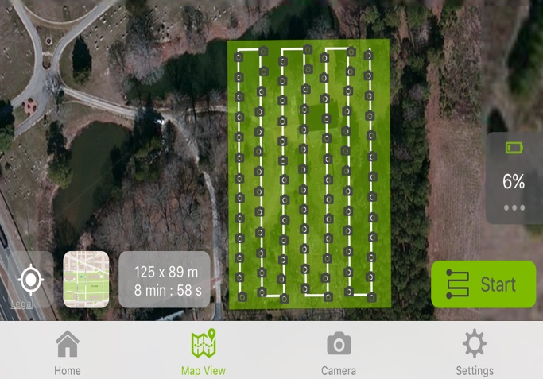
Fig. 4. Map demonstrating orientation and extent of transects as well as route of UAV.

Image/Image Processing
In order to process the images captured by the DJI Phantom’s visible light camera, the team generated a photo mosaic as an effective way of analyzing the field data collectively. The term photo mosaic refers to one complete image that is formulated by the piecing together of multiple images. The images taken during the flight along the transects were composed into a photo mosaic using the image processing software Pix4D, which converts a multitude of images into "geo-referenced 2D mosaics and 3D models", useful for mapping and modeling. A 64-bit trial version of Pix4D Mapper (Discovery Version) for Macintosh OS X was downloaded to a 256GB 2015 MacBook Pro Retina with 2.7GHZ processor and 8 gigabytes of RAM [3].
The 147 images collected and stored as JPEG on SD cards provided with the DJI Phantom were transferred to an 8 GB flash drive. From that point forward, the images were inserted into the Pix4D Mapper application project folder. Then the software took the individual images taken along the transects determined the overlap between each image by searching for commonalities, and then composed the images collectively into a 3D photo mosaic model of St. Luke’s church and its parameters. Nineteen hours were taken to fully process the 147 images from the three trips to create the photo mosaic. In addition to creation of the photo mosaic, the team provided St. Luke's with elevation models of the property, a point cloud, and 3D mesh and a fly-through of the property.
Selecting the Pix4d software became an excellent resource for the research team. By downloading the software, Pix4D provided an application for mobile devices that was used in the field to map transects for the automated flight. Once transects were mapped, the UAV automatically flew at a constant elevation of 50 meters along the route taking aerial images at every point mapped until completion. This resulted in 147 overlapping images that would later be used to produce a larger mosaic image and 3D point cloud. The benefit of this automation was that the team did not have to manually fly the UAV. Manual flight of the UAV could have resulted in various elevation changes throughout flight due to the strain of manually trying to make the elevation constant and the chance of over-mapping as well as under-mapping transects points, which could have produced an unreliable geo-referenced photo mosaic of the surveyed area. A manual flight with the UAV, aided in the 3d model and point cloud coming out so well.

Results
The goal of this research being to produce aerial imagery and elevation models that can be used for future use of research exploration on the property of St. Luke’s. In addition to the objective, a point cloud and 3D mesh was produced. Fig 5 is a screenshot of the generated point cloud. A point cloud is series of data points that are defined by X, Y, Z coordinates.
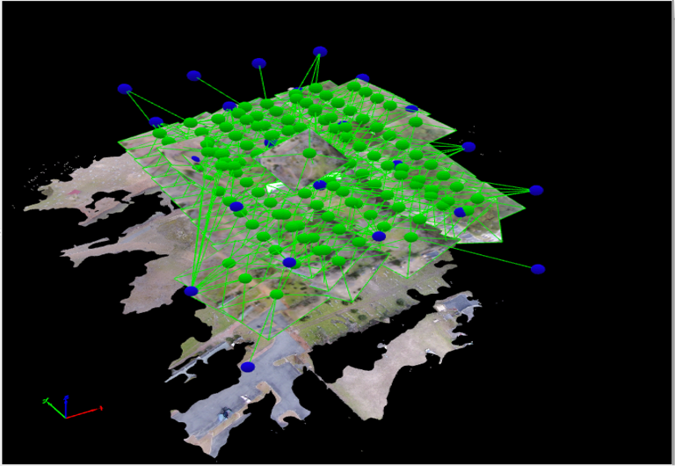
Fig. 5. Point Cloud. Each dot represents an image taken by the UAV. (147 total).
The point cloud was used to create a 3D mesh (Figure 5). Figure 6 is a generated 3D mesh of the entire property (125 x 85 meters) that was surveyed. Figures 7, 8, 9, are the generated 3D meshes of the actual St. Luke’s Church as well. The analysis of the 3D meshes is that they are a realistic and accurate representation of the St. Luke’s Church and surrounding property. Provided is an example of how realistic the 3D meshes is compared to the actual structure. Figure 10 is an actual image of St. Luke’s Church. Figure 11 3D mesh that is taken from the same angle as the Figure 10. It is to be noted, that using a manual flight around the church structures aided the other images that were collected from the computerized flight (using Pix4D mobile application) in creating such an enriched 3D mesh of St. Luke’s. In addition, it is important to note that this level of quality was able to be reached on a total flight time (3 flights) of approximately 26 minutes. The aerial imagery, elevation models, and 3D meshes were all adequate and accurate to be used for future research excavations and exploration for St. Luke’s Church.
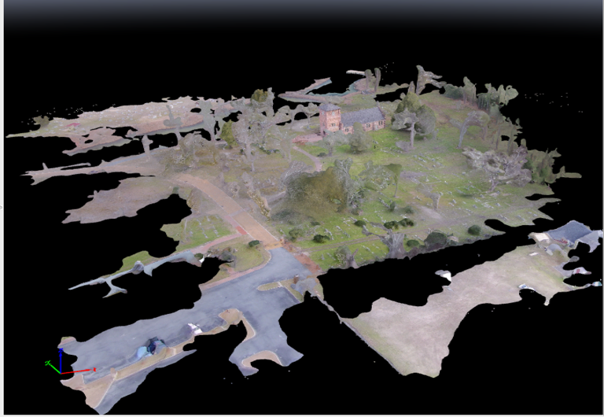
Fig 6. 3D Mesh of entire St. Luke’s Property
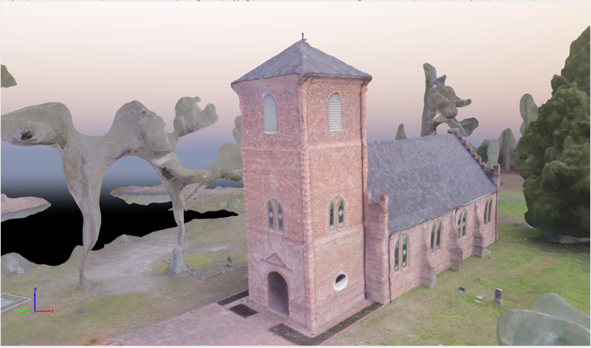
Fig 7. 3D Mesh of St. Luke’s Church [1]
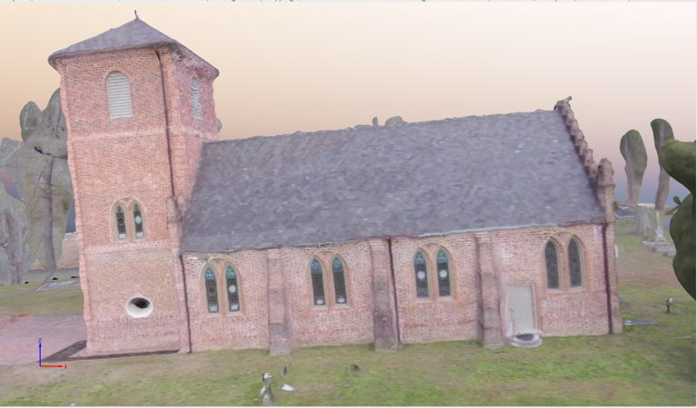
Fig 8. 3D Mesh of St. Luke’s Church [2]
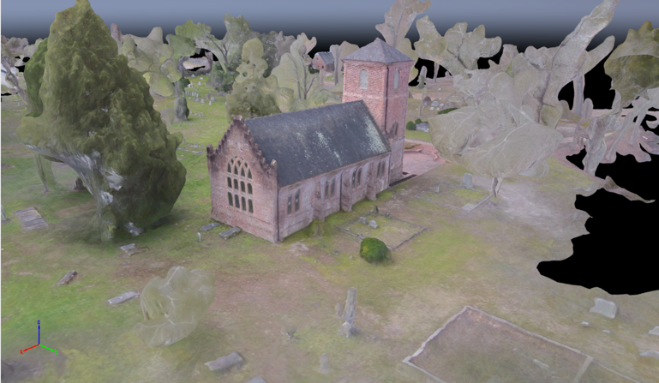
Fig 9. 3D Mesh of St. Luke’s Church [3]
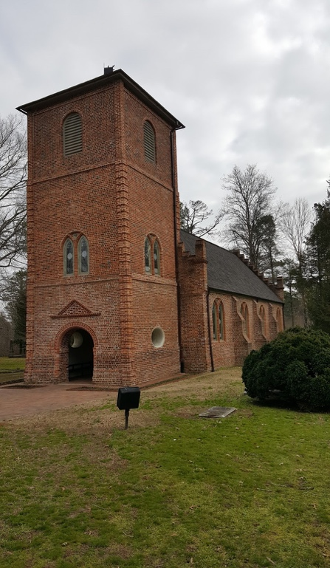
Fig 10. Image taken of the front landscape of St. Luke’s Church
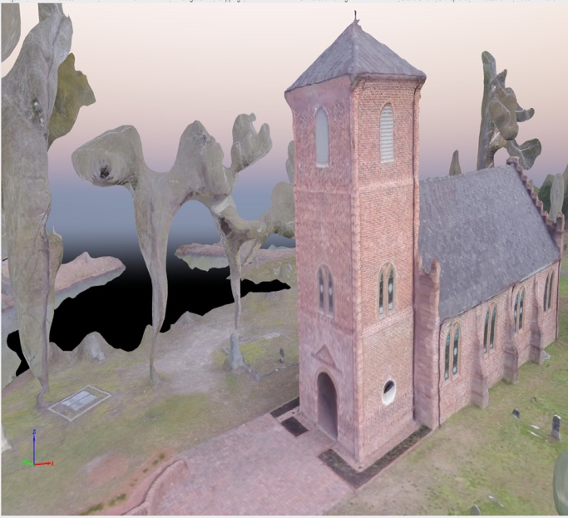
Fig 11. 3D mesh created of front landscape of St. Luke’s Church

conclusion
This research project was successful in that the team achieved the primary objective of producing structural and elevation models from aerial imagery derived from the DJI Phantom 2+ UAV. This likewise fulfilled the UAV team’s secondary objective to make this data available to the church so that it could be used in future archaeological and landscape studies. By creating 3d structural and elevation models for St. Luke's Church the team has demonstrated that such approaches using UAVs and software such as Pix4D are both inexpensive and effective approaches to studying historic properties. The data sets that have been created can be easily added to Geographic Information Systems (GIS) which many properties use these days to understand the landscape and structures they have on them from a broader perspective. New data can be easily added to these systems and UAV derived data should be considered a viable alternative to more expensive approaches such as those flown from aircraft. Conclusively, like St. Luke’s Church, other historic properties can benefit from this form of research by using the methodology, products, and approach laid out in this paper.

Acknowledgement
The team extends a hand of appreciation to Clay Swindell for his guidance, contributions, and help with completing this research. Also, the team acknowledges Dr. Linda Hayden for the research opportunity that was made possible through the CERSER program, Dr. Malcolm LeCompte for supplying the DJI Phantom 2 Vision+. The UAV team also would like to express our gratitude to St. Luke’s Church for providing access to the property.

References
- Phantom 2 Vision+ User Manual, V1.6, DJI Co., Los Angeles, CA, 2016, pp. 5-12.
- Digital globe, USDA Farm Service Agency Map Data (2016). Google Maps [Online]. Available: https://www.google.com/maps
- Pix4D Co. (2016). Pix4D: simply powerful [Online]. Available: https://pix4d.com/
- Matthew R. Laird, Ph.D, and Anthony W. Smith, M.A. ARCHAEOLOGICAL TESTING ASSOCIATED WITH A DRAINAGE INSTALLATION PROJECT AT ST. LUKE’S CHURCH (046-0024/44IW0271) ISLE OF WIGHT COUNTY, VIRGINIA. Williamsburg, VA: James River Institute for Archaeology, Inc., 2012. Print.

- Swindell, E. et al. Remote Sensing Archeological Sites Through Unmanned Aerial Vehicle (U.A.V.) Imaging. Elizabeth City, NC: Center of Excellence in Remote Sensing Education and Research, 2015. Print.

